Experiment no:3 192011340

P.keerthi

### AIM:

Configuration of Bus Topology using packet tracer

### REQUIREMENTS:

1. End device - They are the devices through which we can pass message from one device to another and they are interconnected.
2. Switch/Hub - Interface Between two devices.

Cable - Used to connect two devices

Procedure:

STEP 1: Click on end devices, select generic Pc’s drag and drop it on the

window. Click on SWITCH drag and drop it on the window.

STEP 2: Select the straight through cable and connect all end device to switch. Assign the IP address for all end devices. (Double click the end device Select →

desktop → IP configuration static)

STEP 3: Now set the IP address to Host A (192.168.1.1) in static mode. Similarly set IP address for Host B (192.168.1.2) and Host C (192.168.1.3)

STEP 4: To view the IP address, give ipconfig command in command prompt. Using ping command, we can establish communication between two host devices.

STEP 5: Now display the packet transmission in simulation mode.

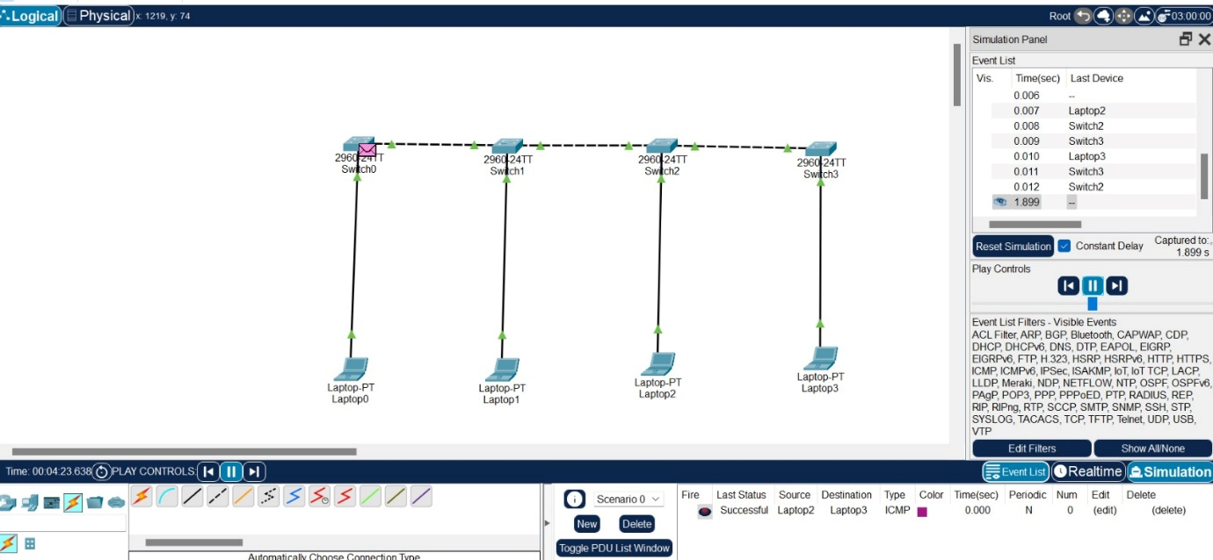

RESULT:

Configuration of Ring Topology using Packet Tracer communication is verified successful.